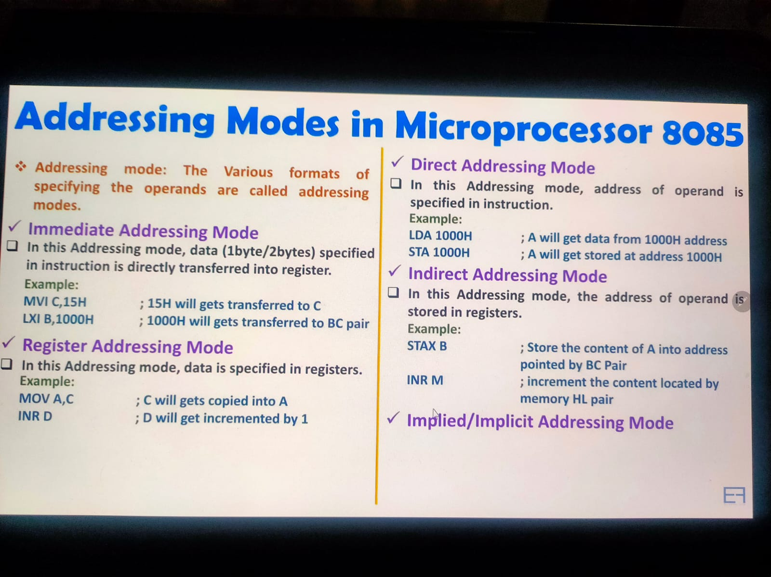

Register Indirect Addressing Mode -> IN this type of register indirect addressing mode the address of the data is present inside another register.

And address of the data present as a content for another register.  
  
Implied/ Implicit Addressing Modes -> IN this type of addressing Mode operand itself is the content of accumulator.